**Evaluating trophic cascades as drivers of regime shifts in different ocean ecosystems**

**Summary:**

This research looks at the roles that trophic cascades play in three different ocean ecosystems. They hope to understand how these persistent trophic cascades can be a part of a regime shift and also if these shifts are driven more by top-down or bottom-down forcing. Regime shifts caused by trophic cascades in pelagic or terrestrial systems are thought to be driven through top-down predation or bottom-up forcing from lower level organisms in the food web. The research utilized existing studies with the goal of gaining a better understanding for the conditions needed for a trophic cascade regime shift and how these changes are driven. The research utilized time series data from three regions including the Black Sea, The Baltic Sea and eastern Scotian Shelf.

They utilized a simple method to isolate the influence of top-down and bottom-up drivers in creating trophic cascade regime shifts. An ideal clean scientific finding would have found consistent proof of top-down predation driving trophic cascades that led to large scale regime shifts. However, the findings were more complex than that depending on multiple factors found across all three sites. In the Black Sea they found strong support for a top-down trophic cascade regime shift driven by gelatinous predators. In the Baltic Sea they found evidence of both top-down but also found evidence of bottom-down forcing from due to salinity. In the Scotian Shelf they found evidence that stratification played a greater role in ecosystem changes then the groundfish change.

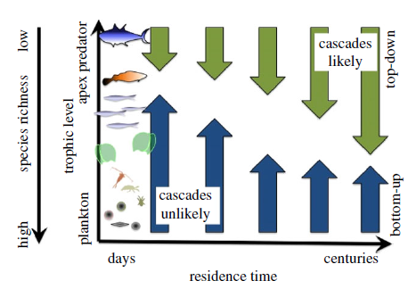

**Figure 1:** Hypothesis of top-down and bottom-up forcing

The research also suggests that trophic cascades might be rare and influenced by bottom-up forcing. They proposed a mixed model shown in Figure 1, where these two forces compete and where top-down forcing is more present in ecosystems with less diversity. They also propose focusing on bottom-up forcing as the dominant mechanism in regime shift changes for pelagic systems.

**Discussion**

My understanding of this research is that it does a good job of trying to understand very complex systems by looking at three separate regions where this phenomenon occurs. To build upon this research I think it would be important to gather more data and focus on one particular ecosystem over a longer duration of time. I would see next steps as at least three separate hypotheses including examining each of the three ecosystems presented in this research. I agreed with the outcomes but as a criticism found the data and methods to be my main concern as they seemed to be analyzing large complex phenomenon with what seemed like not enough data that was derived from past research. The use of computational methods utilizing big data and machine learning could also potentially help find relations that would be complex or tedious to determine by hand.

**Reference:**

Pershing AJ, Mills KE, Record NR, Stamieszkin K, Wurtzell KV, Byron CJ, Fitzpatrick D, Golet

WJ, Koob E. 2015 Evaluating trophic cascades as drivers of regime shifts in different ocean ecosystems. Phil. Trans. R. Soc. B 370: 20130265.